Mixture Word Problems  Handout-KEY | Name_________________________  Date__________________________
Objective: Solving word problems involving mixture.
Segment 1: Strategies for solving mixture problems
Mixture problems occur in many different situations. For example, a store owner may wish to combine two goods in order to sell a new blend at a given price. A chemist may wish to obtain a solution of a desired strength by combining other solutions.

Mixture problems are word problems where items or quantities of different values are mixed together. They involve creating a mixture from two or more things, and then determining some quantity (percentage, price, etc) of the resulting mixture.
1st mixture + 2nd mixture = total mixture
There are two types of mixture problems:
- those in which the items remain separate (ex. quantities of different costs are mixed together : two different types of candy)
The format for mixture problems involving quantities of different costs is:
[1st amount * 1st cost] + [2nd amount * 2nd cost] = [total amount * final cost]
- those in which two elements blend (ex. different liquids are mixed together changing the concentration of the mixture: two different types of chemicals).
The format for mixture problems involving percentages is:
[1st amount * 1st percentage] + [2nd amount * 2nd percentage] = [total amount * final percentage]
A good way to start working on problems like this would be to look at the separate mixture types first and begin with the table. Creating a table will help you to organize the information and find the equation more easily.
The mixture problems may all be solved by using the bucket method. The key to the bucket method is setting up the buckets correctly.

Generally, the buckets will be set up as follows:
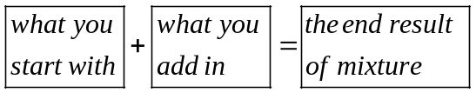

Each bucket must contain two values:
- An amount (liters, tons, pounds, ounces, grams, etc.)
- A type (usually either a percent or a price)

Once all of the buckets are "filled" with an amount and a type, an equation may be determined.
But before you can do a complete mixture problem, you need to recall some basic one variable word problems.
Practice:
(a) If tomatoes cost $2 per pound, how much would you pay for 3.5 pounds? (Answer: $7)
(b) If you have 60 milliliters of a 45% acid solution, how much acid is in the solution? (Answer: 27 milliliter)
Segment 2: Mixture problem involving quantities of different costs
Now, let’s set up a mixture problem involving quantities of different costs.
Remember:
The format for mixture problems involving quantities of different costs is:
[1st amount * 1st cost] + [2nd amount * 2nd cost] = [total amount * final cost]
Practice: Let’s suppose that you work in the grocery store. Suppose macadamia nuts cost $12 per pound and are not selling well because they are too expensive. You want to mix it with cashews that cost $7 per pound. How many pounds of cashews should you combine with 25 pound of macadamia nuts to obtain a mixture that can be sold for $9 per pound?
After you read the problem entirely and get a feel for the whole problem, you first need to set up the table or use bucket method
 | Amount | Cost in $ | Total in $
m. nuts
cashews
Mixture
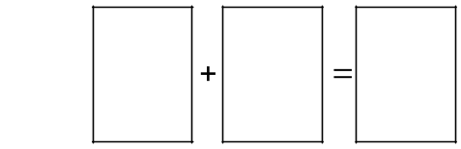
Once you have the table or the buckets, you need to fill in the information.
This is how the table will look: This is how the buckets will look:
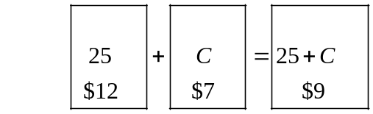
Now, let’s use the information in the table or in buckets to write the equation.
 | Amount in pounds | Cost in $ | Total in $
m. nuts | 25 | 12 | 25(12)
cashews | C | 7 | 7C
Mixture | 25+C | 9 | 9(25+C)
Remember that amount in first mixture plus amount in second mixture equals amount in total mixture, i.e. 1st mixture + 2nd mixture = total mixture.
So the equation will be: 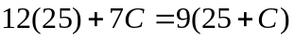 .
The solution of this equation is 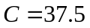pounds.
This means that you should use 25 pounds of macadamia nuts costing $12 per pound and 37.5 pounds of cashews costing $7 per pound to obtain 62.5 pounds of mixture costing $9 per pound.
Also, always remember to check your work. Is 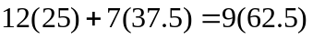?
Example: How many pounds of candy worth $1.20 a pound must be mixed with 10 pounds of candy worth 90 cents a pound to produce a mixture worth $1.00 a pound?
(Answer: 5 lb of the $1.20 candy needs to be added)

Segment 3: Mixture problem involving percents
Now, let set up a mixture problem involving percents.
Example: Let’s suppose that you work in a lab. You need a 15% acid solution for a certain test, but your supplier only ships a 10% solution and a 30% solution. You decide to mix 10% solution with 30% solution, to make your own 15% solution. You need 10 liters of the 15% acid solution. How many liters of 10% solution and 30% solution should you use?
Again, you first need read the problem carefully to set up the table or the buckets:
Or
 | Amount in liters | Percent acid | Total in liters
10% solution
30% solution
Mixture

Please try to fill out the table before looking at the completed table on the next page:
Once you have the table, you need to fill in the information.
Or
 | Amount in liters | Percent acid | Total in liters
10% solution | X | .10 | 0.10X
30% solution | 10-X | .30 | .30(10-X)
Mixture | 10 | .15 | .15(10)

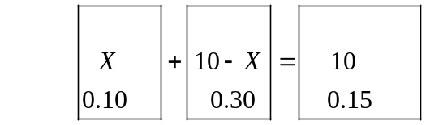

So the equation will be: . The solution of this equation is 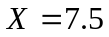liters.
This means that you should use 7.5 liters of 10% solution and 2.5 liters of 30% solution to obtain 10 liters of 15% mixture solution. Don’t forget to check your work.
The next page has a few examples for you to try on your own to test what you have learned:
(Please try to follow these steps for the problems.)
Table: or Bucket Method
1st
2nd
Mixture
Equation:

Solution:

Check:

Problem 1: How many gallons of 30% alcohol solution and how many gallons of 60% alcohol solution must be mixed to produce 18 gallons of 50% solution?
(Answer: 6 gallons of 30% solution and 12 gallons of 60% solution)

Problem 2: How many ounces of pure water must be added to 50 ounces of a 15% saline solution to make a saline solution that is 10% salt?
(Note the percentage for water. "Pure water" contains no salt, so the percent of salt is zero. If, on the other hand, you were trying to increase the salt content by adding pure salt, the percent would have been one hundred.)
(Answer: 25 ounces of pure water)

SELF-REFLECTION ACTIVITY

- Which segment of mixture word problems was most challenging for you?

- What steps are you going to take to learn this subject?

-When do you use addition for the amounts column, and is the addition used for an individual amount or for the mixture amount?

-When do you use subtraction for the amounts column, and is the subtraction used for an individual amount or for the mixture amount? Is the variable before or after the subtraction symbol?

